**Experiment 8**

**Aim:** To create a network topology for simulating VLANs on the switch using Cisco packet tracer

**Theory:**

A Virtual LAN (VLAN) is simply a logical LAN. VLANs have similar characteristics with those of physical LANs, only that with VLANs, you can logically group hosts even if they are physically located on separate LAN segments. Each VLAN can be considered as a separate subnet or broadcast domain. For this reason, to move packets from one VLAN to another, a router or a layer 3 switch is used. VLANs are configured on switches by placing some interfaces into one broadcast domain and some interfaces into another.

**Output:**

**Main:**

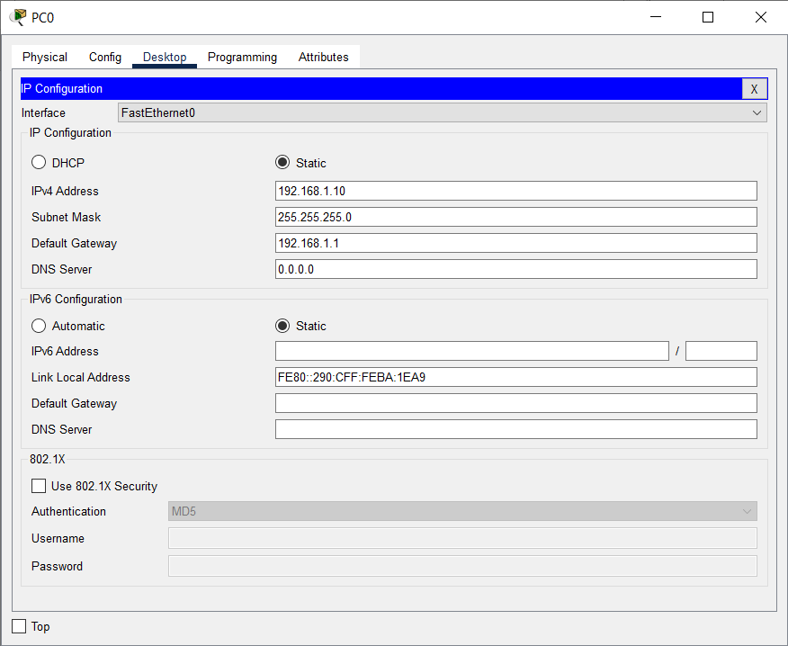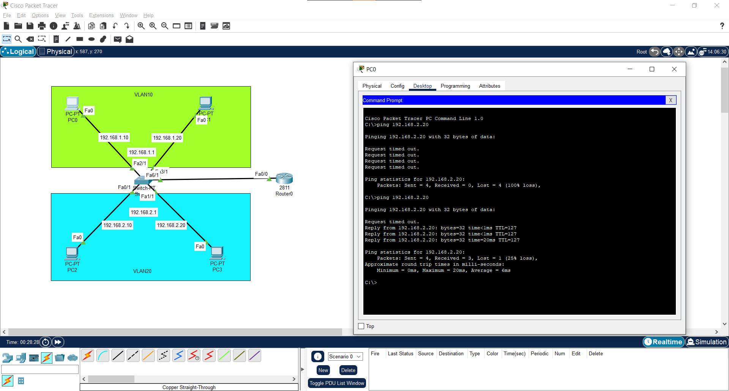**VLAN10 PC Configuration:**

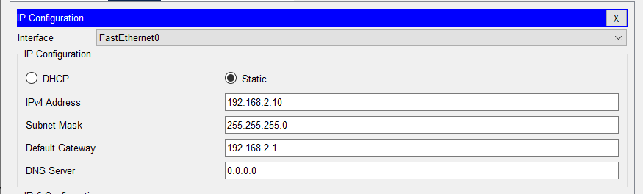**VLAN20 PC Configuration**

**Switch CLI Configuration:** 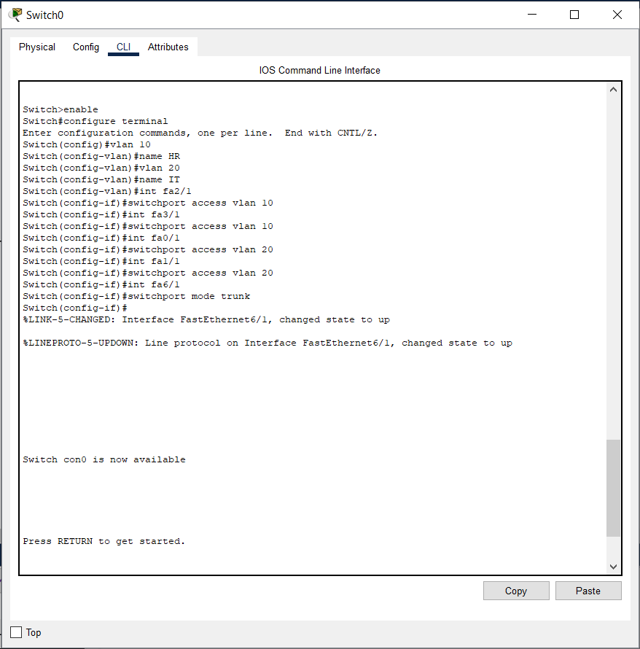

**Router CLI Configuration:**

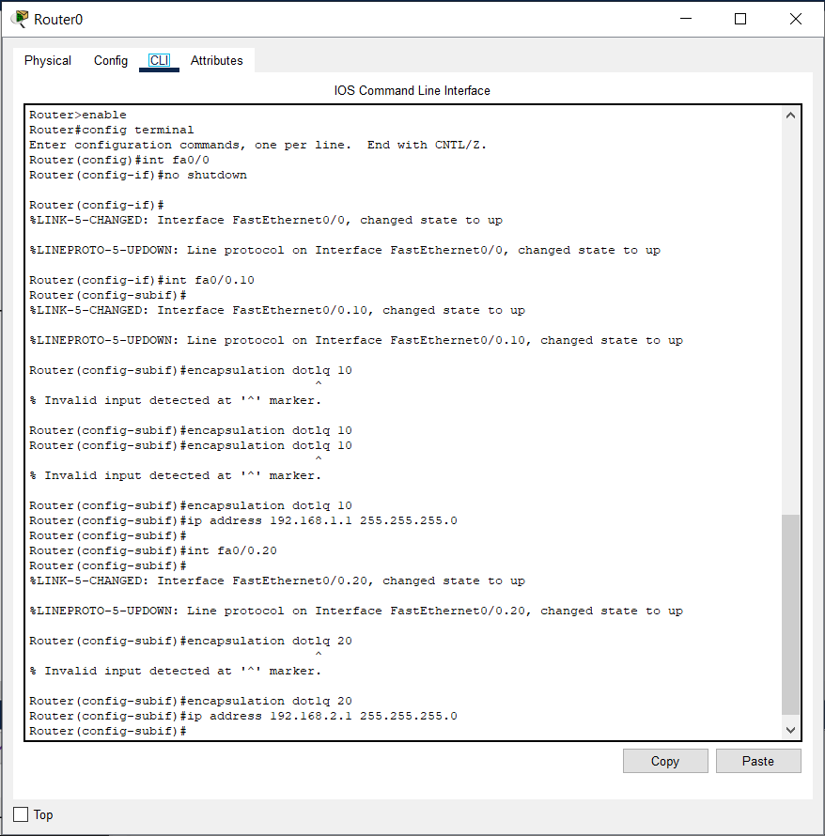

**Conclusion:**